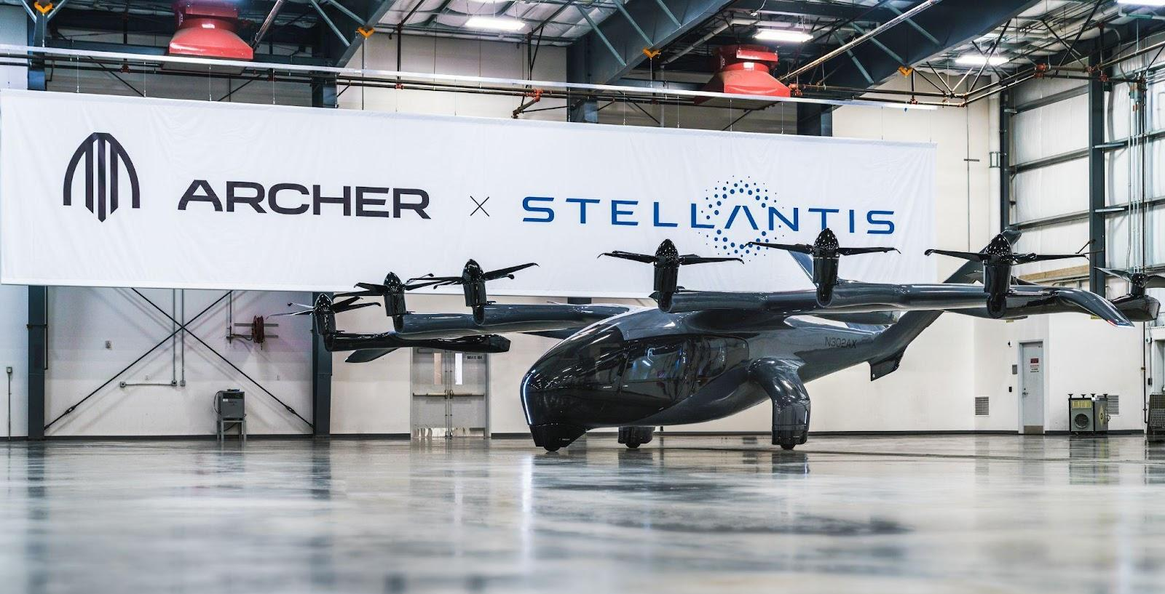
Stellantis et Archer présentent, en première européenne, l’aéronef Midnight eVTOL au Salon du Bourget 2023
AMSTERDAM ET SANTA CLARA, CALIFORNIE, le 9 juin 2023 – Archer Aviation Inc. (NYSE: ACHR) et Stellantis N.V. participeront à la 54ème édition du Salon International de l’Aéronautique et de l’Espace (Salon du Bourget) qui ouvrira ses portes le lundi 19 juin. Une occasion pour partager les avancées en vue de la production en série de l’aéronef Midnight eVTOL d’Archer et la préparation de la commercialisation prévue pour 2025.
Présenté en première européenne au Salon du Bourget, le Midnight d’Archer sera l’eVTOL « vedette », exposé au centre de l’espace Paris Air Mobility situé au hall 5. Dédié aux dernières innovations et technologies émergentes dans le domaine de l’eVTOL, cet espace réunira tous les acteurs clés du secteur pour trois jours de discussions axées sur l’évolution de la mobilité aérienne et sur l’avenir de l’aérospatiale.
Unique en son genre dans le secteur de la mobilité aérienne urbaine, ce partenariat s’appuiera sur les forces et compétences respectives de chaque société pour commercialiser le Midnight. Archer apporte l’équipe de renommée mondiale de son eVTOL, son moteur électrique et ses experts en certification, tandis que Stellantis fournit son expertise et sa technologie de fabrication de pointe, l’expertise de ses équipes et son capital. Ce partenariat devrait permettre d’accélérer la production de l’aéronef afin de respecter les plans de commercialisation d’Archer, tout en consolidant la mise sur le marché de son appareil en lui permettant plusieurs centaines de millions de dollars d’économies lors de la montée en puissance de la production.
# # #

À propos d’Archer
Archer conçoit et développe des aéronefs électriques à décollage et atterrissage verticaux destinés aux réseaux de mobilité aérienne en milieu urbain. Archer se donne pour mission d’ouvrir la mobilité aérienne et de réinventer la manière dont chacun de nous se déplace et passe son temps. L’équipe d’Archer est basée à Santa Clara en Californie. Plus d’infos sur https://archer.com

À propos de Stellantis
Stellantis N.V. (NYSE: STLA / Euronext Milan: STLAM / Euronext Paris: STLAP) fait partie des principaux constructeurs automobiles et fournisseurs de services de mobilité internationaux. Abarth, Alfa Romeo, Chrysler, Citroën, Dodge, DS Automobiles, Fiat, Jeep®, Lancia, Maserati, Opel, Peugeot, Ram, Vauxhall, Free2move et Leasys : emblématiques et chargées d’histoire, nos marques insufflent la passion des visionnaires qui les ont fondées et celle de nos clients actuels au cœur de leurs produits et services avant-gardistes. Forts de notre diversité, nous façonnons la mobilité de demain. Notre objectif : devenir la plus grande tech company de mobilité durable, en termes de qualité et non de taille, tout en créant encore plus de valeur pour l’ensemble de nos partenaires et des communautés au sein desquelles nous opérons. Pour en savoir plus, www.stellantis.com/fr.

Contacts médias
Archer:
The Brand Amp - Archer@TheBrandAmp.com

Stellantis:
Fernão SILVEIRA +31 6 43 25 43 41 - fernao.silveira@stellantis.com
Valérie GILLOT +33 6 83 92 92 96 - valerie.gillot@stellantis.com

Archer Forward Looking Statements
This press release contains forward looking statements regarding Archer’s future business plans and product roadmaps, including statements regarding the timing of Archer’s development, commercialization, and certification of its eVTOL aircraft. These forward looking statements are only predictions and may differ materially from actual results due to a variety of factors. The risks and uncertainties that could cause actual results to differ from the results predicted are more fully detailed in Archer’s filings with the Securities and Exchange Commission, including its most recent Annual Report on Form 10-K, available at www.sec.gov. In addition, please note that any forward looking statements contained herein are based on assumptions that Archer believes to be reasonable as of the date of this press release. Archer undertakes no obligation to update these statements as a result of new information or future events.

Stellantis Forward Looking Statements
This communication contains forward-looking statements. In particular, statements regarding future events and anticipated results of operations, business strategies, the anticipated benefits of the proposed transaction, future financial and operating results, the anticipated closing date for the proposed transaction and other anticipated aspects of our operations or operating results are forward-looking statements. These statements may include terms such as “may”, “will”, “expect”, “could”, “should”, “intend”, “estimate”, “anticipate”, “believe”, “remain”, “on track”, “design”, “target”, “objective”, “goal”, “forecast”, “projection”, “outlook”, “prospects”, “plan”, or similar terms. Forward-looking statements are not guarantees of future performance. Rather, they are based on Stellantis’ current state of knowledge, future expectations and projections about future events and are by their nature, subject to inherent risks and uncertainties. They relate to events and depend on circumstances that may or may not occur or exist in the future and, as such, undue reliance should not be placed on them.
Actual results may differ materially from those expressed in forward-looking statements as a result of a variety of factors, including: the impact of the COVID-19 pandemic, the ability of Stellantis to launch new products successfully and to maintain vehicle shipment volumes; changes in the global financial markets, general economic environment and changes in demand for automotive products, which is subject to cyclicality; changes in local economic and political conditions, changes in trade policy and the imposition of global and regional tariffs or tariffs targeted to the automotive industry, the enactment of tax reforms or other changes in tax laws and regulations; Stellantis’ ability to expand certain of their brands globally; its ability to offer innovative, attractive products; its ability to develop, manufacture and sell vehicles with advanced features including enhanced electrification, connectivity and autonomous-driving characteristics; various types of claims, lawsuits, governmental investigations and other contingencies, including product liability and warranty claims and environmental claims, investigations and lawsuits; material operating expenditures in relation to compliance with environmental, health and safety regulations; the intense level of competition in the automotive industry, which may increase due to consolidation; exposure to shortfalls in the funding of Stellantis’ defined benefit pension plans; the ability to provide or arrange for access to adequate financing for dealers and retail customers and associated risks related to the establishment and operations of financial services companies; the ability to access funding to execute Stellantis’ business plans and improve its businesses, financial condition and results of operations; a significant malfunction, disruption or security breach compromising information technology systems or the electronic control systems contained in Stellantis’ vehicles; Stellantis’ ability to realize anticipated benefits from joint venture arrangements; disruptions arising from political, social and economic instability; risks associated with our relationships with employees, dealers and suppliers; increases in costs, disruptions of supply or shortages of raw materials, parts, components and systems used in Stellantis’ vehicles; developments in labor and industrial relations and developments in applicable labor laws; exchange rate fluctuations, interest rate changes, credit risk and other market risks; political and civil unrest; earthquakes or other disasters; risks and other items described in the Company’s Annual Report on Form 20-F for he year ended December 31, 2022 and Current Reports on Form 6-K and amendments thereto filed with the SEC; and other risks and uncertainties.

Any forward-looking statements contained in this communication speak only as of the date of this document and Stellantis disclaims any obligation to update or revise publicly forward-looking statements. Further information concerning Stellantis and its businesses, including factors that could materially affect Stellantis’ financial results, is included in Stellantis’ reports and filings with the U.S. Securities and Exchange Commission and AFM.

