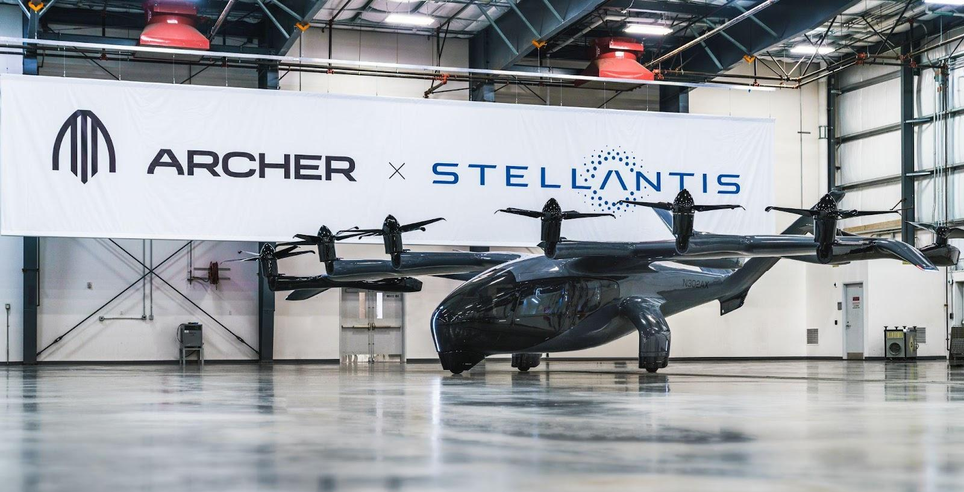
Stellantis and Archer Host European Debut of Midnight eVTOL Aircraft at 2023 Paris Air Show
AMSTERDAM and SANTA CLARA, CALIFORNIA, June 9, 2023 - Archer Aviation Inc. (NYSE: ACHR) and Stellantis N.V. will attend the 54th edition of the 2023 Paris Air Show, starting June 19, 2023, to share progress toward scaling manufacturing of Archer’s Midnight eVTOL aircraft as Archer prepares for planned commercialization in 2025.
Archer’s Midnight aircraft will be the featured eVTOL aircraft at the Paris Air Show, positioned in the center of the Air Mobility event, which is located in Hall 5 at Le Bourget Airport. Dedicated to the latest innovations and emerging technologies in eVTOL, the Paris Air Show’s Air Mobility event will bring together key players of this sector with three days of discussions focused on the maturation of advanced air mobility and its impact on the future of aerospace.
This unique partnership in the eVTOL aircraft industry between Archer and Stellantis will leverage each company’s respective strengths and competencies to bring the Midnight aircraft to market at scale. To complement Archer’s world-class team of eVTOL aircraft, electric powertrain and certification experts, Stellantis is contributing advanced manufacturing technology and expertise, experienced personnel and capital to the partnership. This combination is intended to enable the rapid scaling of aircraft production to meet Archer’s commercialization plans, while allowing Archer to strengthen its path to commercialization by helping it avoid hundreds of millions of dollars of spending during the manufacturing ramp up phase.
# # #

About Archer
Archer is designing and developing electric vertical takeoff and landing aircraft for use in urban air mobility networks. Archer’s mission is to unlock the skies, freeing everyone to reimagine how they move and spend time. Archer’s team is based in Santa Clara, CA.

To learn more, visit www.archer.com.

About Stellantis
Stellantis N.V. (NYSE: STLA / Euronext Milan: STLAM / Euronext Paris: STLAP) is one of the world’s leading automakers and a mobility provider. Its storied and iconic brands embody the passion of their visionary founders and today’s customers in their innovative products and services, including Abarth, Alfa Romeo, Chrysler, Citroën, Dodge, DS Automobiles, Fiat, Jeep®, Lancia, Maserati, Opel, Peugeot, Ram, Vauxhall, Free2move and Leasys. Powered by our diversity, we lead the way the world moves – aspiring to become the greatest sustainable mobility tech company, not the biggest, while creating added value for all stakeholders as well as the communities in which it operates.

For more information, visit www.stellantis.com.

Archer Media Contacts:
The Brand Amp - Archer@TheBrandAmp.com

Stellantis Media Contacts
Fernão SILVEIRA +31 6 43 25 43 41 - fernao.silveira@stellantis.com
Valerie Gillot +33 6 83 92 92 96 - valerie.gillot@stellantis.com

Archer Forward Looking Statements
This press release contains forward looking statements regarding Archer’s future business plans and product roadmaps, including statements regarding the timing of Archer’s development, commercialization, and certification of its eVTOL aircraft. These forward looking statements are only predictions and may differ materially from actual results due to a variety of factors. The risks and uncertainties that could cause actual results to differ from the results predicted are more fully detailed in Archer’s filings with the Securities and Exchange Commission, including its most recent Annual Report on Form 10-K, available at www.sec.gov. In addition, please note that any forward looking statements contained herein are based on assumptions that Archer believes to be reasonable as of the date of this press release. Archer undertakes no obligation to update these statements as a result of new information or future events.

Stellantis Forward Looking Statements
This communication contains forward-looking statements. In particular, statements regarding future events and anticipated results of operations, business strategies, the anticipated benefits of the proposed transaction, future financial and operating results, the anticipated closing date for the proposed transaction and other anticipated aspects of our operations or operating results are forward-looking statements. These statements may include terms such as “may”, “will”, “expect”, “could”, “should”, “intend”, “estimate”, “anticipate”, “believe”, “remain”, “on track”, “design”, “target”, “objective”, “goal”, “forecast”, “projection”, “outlook”, “prospects”, “plan”, or similar terms. Forward-looking statements are not guarantees of future performance. Rather, they are based on Stellantis’ current state of knowledge, future expectations and projections about future events and are by their nature, subject to inherent risks and uncertainties. They relate to events and depend on circumstances that may or may not occur or exist in the future and, as such, undue reliance should not be placed on them.
Actual results may differ materially from those expressed in forward-looking statements as a result of a variety of factors, including: the impact of the COVID-19 pandemic, the ability of Stellantis to launch new products successfully and to maintain vehicle shipment volumes; changes in the global financial markets, general economic environment and changes in demand for automotive products, which is subject to cyclicality; changes in local economic and political conditions, changes in trade policy and the imposition of global and regional tariffs or tariffs targeted to the automotive industry, the enactment of tax reforms or other changes in tax laws and regulations; Stellantis’ ability to expand certain of their brands globally; its ability to offer innovative, attractive products; its ability to develop, manufacture and sell vehicles with advanced features including enhanced electrification, connectivity and autonomous-driving characteristics; various types of claims, lawsuits, governmental investigations and other contingencies, including product liability and warranty claims and environmental claims, investigations and lawsuits; material operating expenditures in relation to compliance with environmental, health and safety regulations; the intense level of competition in the automotive industry, which may increase due to consolidation; exposure to shortfalls in the funding of Stellantis’ defined benefit pension plans; the ability to provide or arrange for access to adequate financing for dealers and retail customers and associated risks related to the establishment and operations of financial services companies; the ability to access funding to execute Stellantis’ business plans and improve its businesses, financial condition and results of operations; a significant malfunction, disruption or security breach compromising information technology systems or the electronic control systems contained in Stellantis’ vehicles; Stellantis’ ability to realize anticipated benefits from joint venture arrangements; disruptions arising from political, social and economic instability; risks associated with our relationships with employees, dealers and suppliers; increases in costs, disruptions of supply or shortages of raw materials, parts, components and systems used in Stellantis’ vehicles; developments in labor and industrial relations and developments in applicable labor laws; exchange rate fluctuations, interest rate changes, credit risk and other market risks; political and civil unrest; earthquakes or other disasters; risks and other items described in the Company’s Annual Report on Form 20-F for he year ended December 31, 2022 and Current Reports on Form 6-K and amendments thereto filed with the SEC; and other risks and uncertainties.

Any forward-looking statements contained in this communication speak only as of the date of this document and Stellantis disclaims any obligation to update or revise publicly forward-looking statements. Further information concerning Stellantis and its businesses, including factors that could materially affect Stellantis’ financial results, is included in Stellantis’ reports and filings with the U.S. Securities and Exchange Commission and AFM.

